Lindenmayer Systems

example: <https://joshuadavis.com/Lindenmayer-systems>

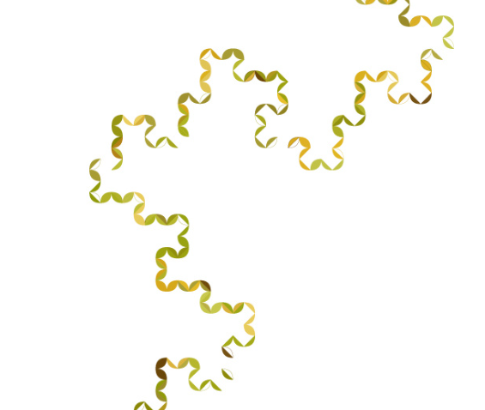

Designer Joshua Davis uses the Lindenmayer System in the linked example.

‘L-systems’ for short, these processes produce varied fractal-like forms through simple and iterative rule sets. The emergent aspect of these designs could be described as the meta structures which appear after many iterations. Variables can enhance the possibility of complex and pseudo-random outcomes in L-systems. Joshua Davis’ portfolio mostly includes simple geometric expressions –resembling “Heighway Dragon Curve” forms – but these plant-like branched forms that hint at the more complex possibilities achievable with L-Systems.

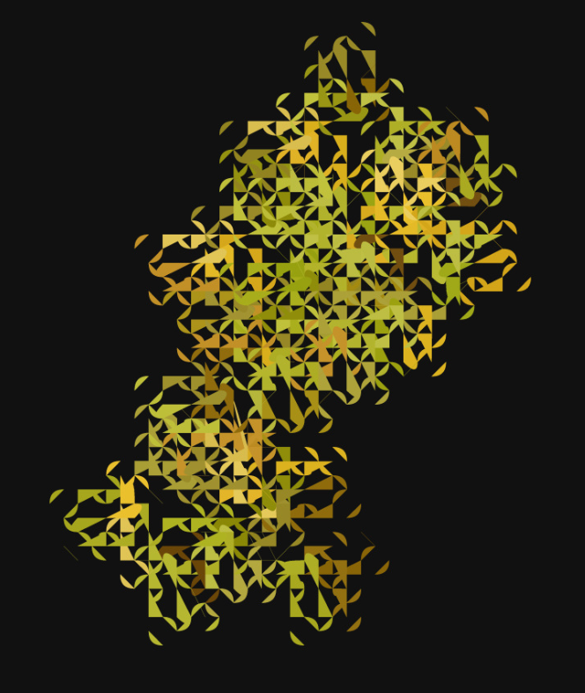

I am interested by L-Systems because they now commonly feature in contemporary games and films which employ procedural content generation, despite the principle first being described in 1968. They are useful for generating botanical models. I have an interest in referencing botanical forms in art and design and may try this method through my own coding.